|  |  |
| --- | --- |
| linear IPS | Year 12 Methods  TEST 7 June 2019    TIME: 45 minutes working  **Calculator Assumed**  44 Marks 6 Questions |

Name: _______________________________ Teacher: ___________________________

**Note: All part questions worth more than 2 marks require working to obtain full marks.**

**Question 1 (5 marks)**

1. Differentiate $x\sin{x}$ (2 marks)
2. Hence find $\int_{0}^{\frac{π}{2} }{x\cos{x dx}}$**using** the result in(a) above. (3 marks)

Page | **2**

**Question 2 (3 marks)**

Determine the *x*-coordinates of all points on the graph of $f\left(x\right)=2\cos\left(x\right)+x$ for $-π≤x≤ π$ where the tangent line is horizontal. (Justify your answers)

**Question 3 (7 marks)**

A survey conducted by a local bank shows that 75% of its customers use an ATM at least once a month.

1. Find the probability that in a random sample of 8 customers, **at least 75%** of them use an ATM machine at least once a month. (2 marks)
2. If the random variable X follows a binomial distribution with n=12 and p=0.75, what is the mean of this distribution and what is P $($ X $≥$ mean $)$? (3 marks)
3. **If the sample size became very large what would you expect P($X ≥$** **mean) to approach? Briefly explain your answer. (2 marks)**

**Question 4 (10 marks)**

The discrete random variable X can only take the values 2, 3 or 4. For these values the cumulative distribution function is defined by



for $x = 2, 3 and 4$, where $k$ is a positive constant integer.

1. Find the value for $k.$ (3 marks)
2. Complete the following table for X. (3 marks)

|  |  |  |  |
| --- | --- | --- | --- |
| $$X$$ | $$2$$ | $$3$$ | $$4$$ |
| $$P(X≤x)$$ |  |  |  |
| $$P(X=x)$$ |  |  |  |

1. Hence find $E(X)$ and $SD(X)$. (2 marks)
2. Calculate $Var\left(3-2X\right)$ giving your answer to 2 decimal places. (2 marks)

**Question 5 (8 marks)**

Consider the function  where  is in radians.

1. Sketch  on the axes below for  on the axes below.

Clearly label undefined points (if any). (3 marks)

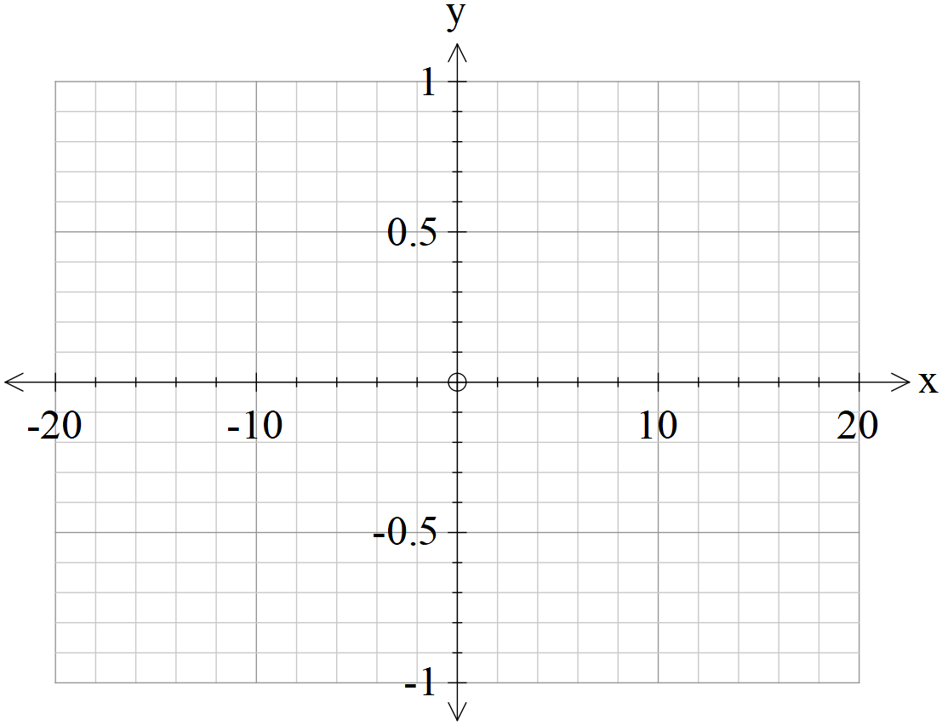

1. As  approaches zero from the positive side, state the value that approaches.

(1 mark)

1. As  approaches zero from the negative side, state the value that approaches.

(1 mark)

1. Use the above to define a value for as approaches zero, that is the following limit  . (1 mark)

It can be shown that  .

1. Using the fact that and the above results, show that .

(2 marks)

**Question 6 (11 marks)**

A game is played by throwing two standard six-sided dice into the air once. The sum of the uppermost numbers are added together and if the sum is greater than 8 the player wins $5.

Determine:

1. the probability of winning $5 in one game. (2 marks)
2. the probability of winning exactly $15 in 5 games. (3 marks)
3. the probability of winning at least $15 in at most 5 games. (3 marks)
4. the minimum number of games to be played so that the probability of winning at least $15 is greater than 0.47. (Justify) (3 marks)

**Working out space**

**Working out space**